The Emma Beeney Award

For outstanding service to the Village of Etchingham

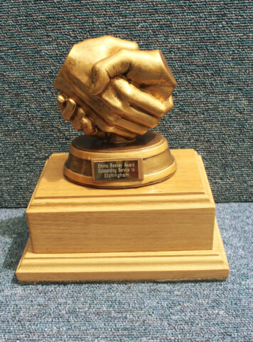
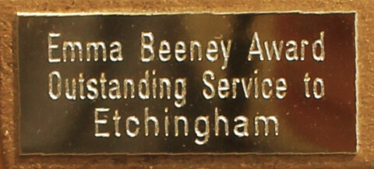
The inaugural recipient of the award in 2021 has been chosen by Parish Council, future recipients will be selected from nominations received during the year from village residents, nominations can be made at any time during the year up to December 31st.

Recipients of the award 2021

Etchingham Community in Action

{Clara Batten & the Volunteer Team}
Clara and her team of amazing volunteers provided much needed support to members of the Etchingham community throughout the Covid-19 Pandemic. They were able to do grocery shops, pick up medication, or just be a friendly voice on the phone, for those residents unable to leave their homes during lockdown.

About the award;
An award, in memory of Emma Beeney, given to an Etchingham resident, or group of residents, for outstanding service to the Parish of Etchingham during the previous year. Awarded to the person, or group, selected by the judging panel from all the nominations received during the calendar year. Recipients will hold the award for one year.

Who is eligible;
Any person who is resident in, or has an active role in the village of Etchingham.
A village based group that has the majority of members who are residents of Etchingham.
The person or group nominated must have carried out an activity during the year that has been an outstanding achievement and has benefited the community of Etchingham.
There is no restriction on who can be nominated for the award, every Etchingham resident or Etchingham based group is eligible to be nominated.
The same person or group can receive the award more than once, but the award must be for a completely different activity each time.
Parish Councillors can nominate residents for the award , they are also eligible to be nominated, if a Parish Councillor has nominated a resident or has themselves been nominated they cannot participate in the decision making process.

Frequency of the award;
To be awarded annually, if there are nominations during the calendar year, if there are not any nominations during the year the recipient will hold the award for a further year.
Awarded at the Parish Council Annual General Meeting which is normally held in May.

Who selects the winner of the award;
The selection of the winner will be made by a meeting of all Parish Councillors that are available on the day of the meeting who will consider the merits of all of the nominations. The meeting of the selection committee will be overseen by the Parish Clerk who will record the Minutes of the discussions.
Any Parish Councillor who has nominated a resident, or has been nominated, will not take part in the decision making process. The decision of the award panel will be final and binding.

When will the presentation be made;
The presentation will be made at the Parish Council Annual General Meeting in May.

How to nominate;
Nominations can be made by any resident of Etchingham, or a person whose business or workplace is wholly, or mainly in Etchingham.
Nominations can be made at any time during the calendar year up until December 31st, those nominations will be considered by the judging panel at the start of the following year with a decision in time for the award to be made at the Annual General Meeting.
Nominations can be made at any time during the calendar year, up to and including 31st December, for the award to be made the following May, nominations received after 31st December will be considered the following year.
Nominations can be made using a nomination form which can be obtained from the Parish Clerk.

